33.15: a) Going from the liquid into air:
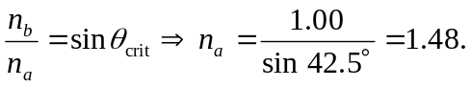
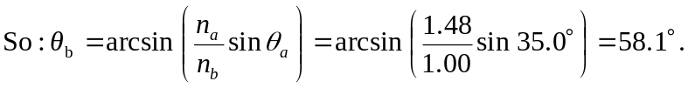
b) Going from air into the liquid:
